Added and created the EC2 with app deployed

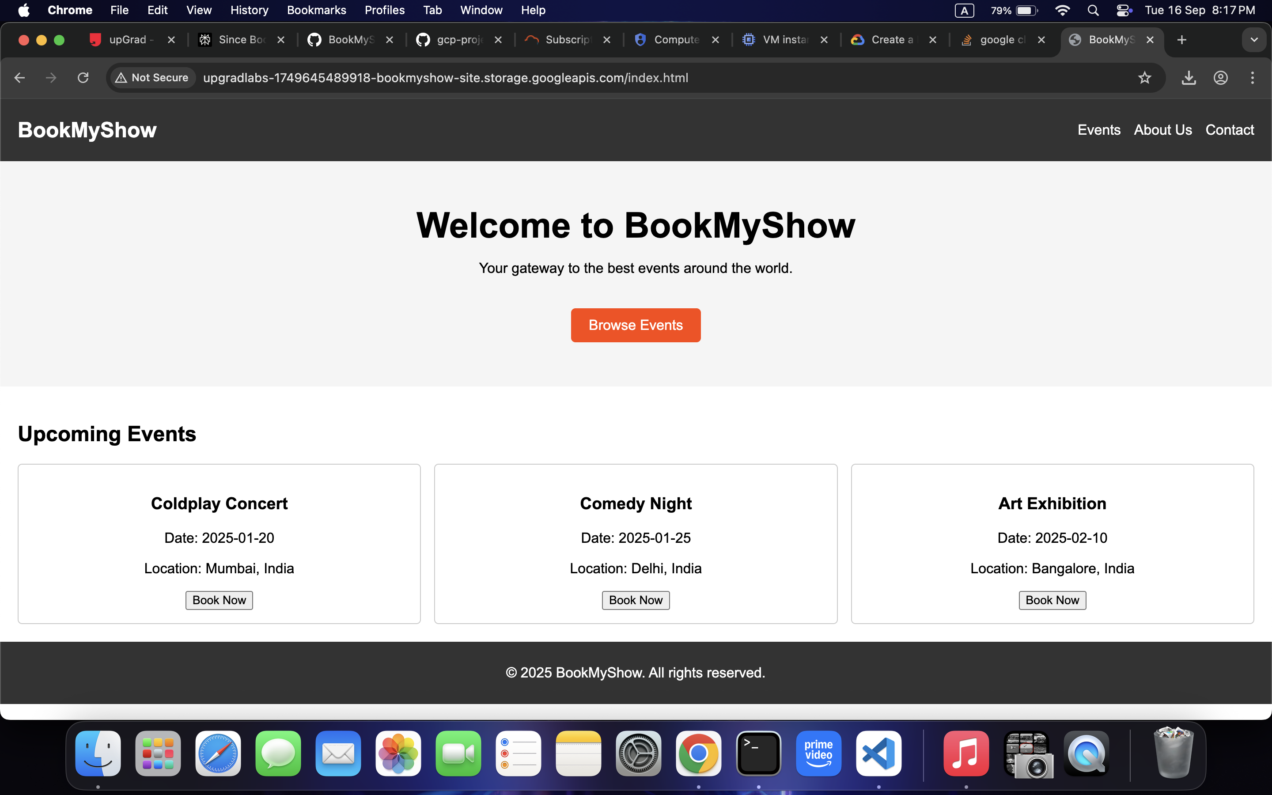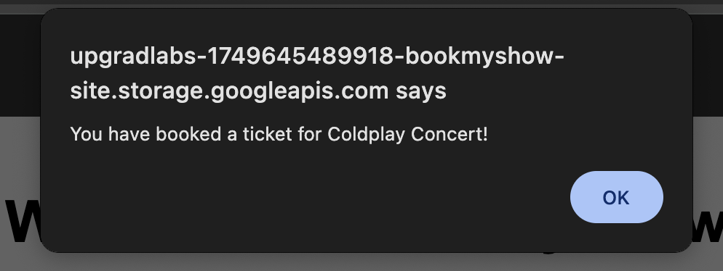

To store docker image, enabled Artifactory API

Ran terraform apply

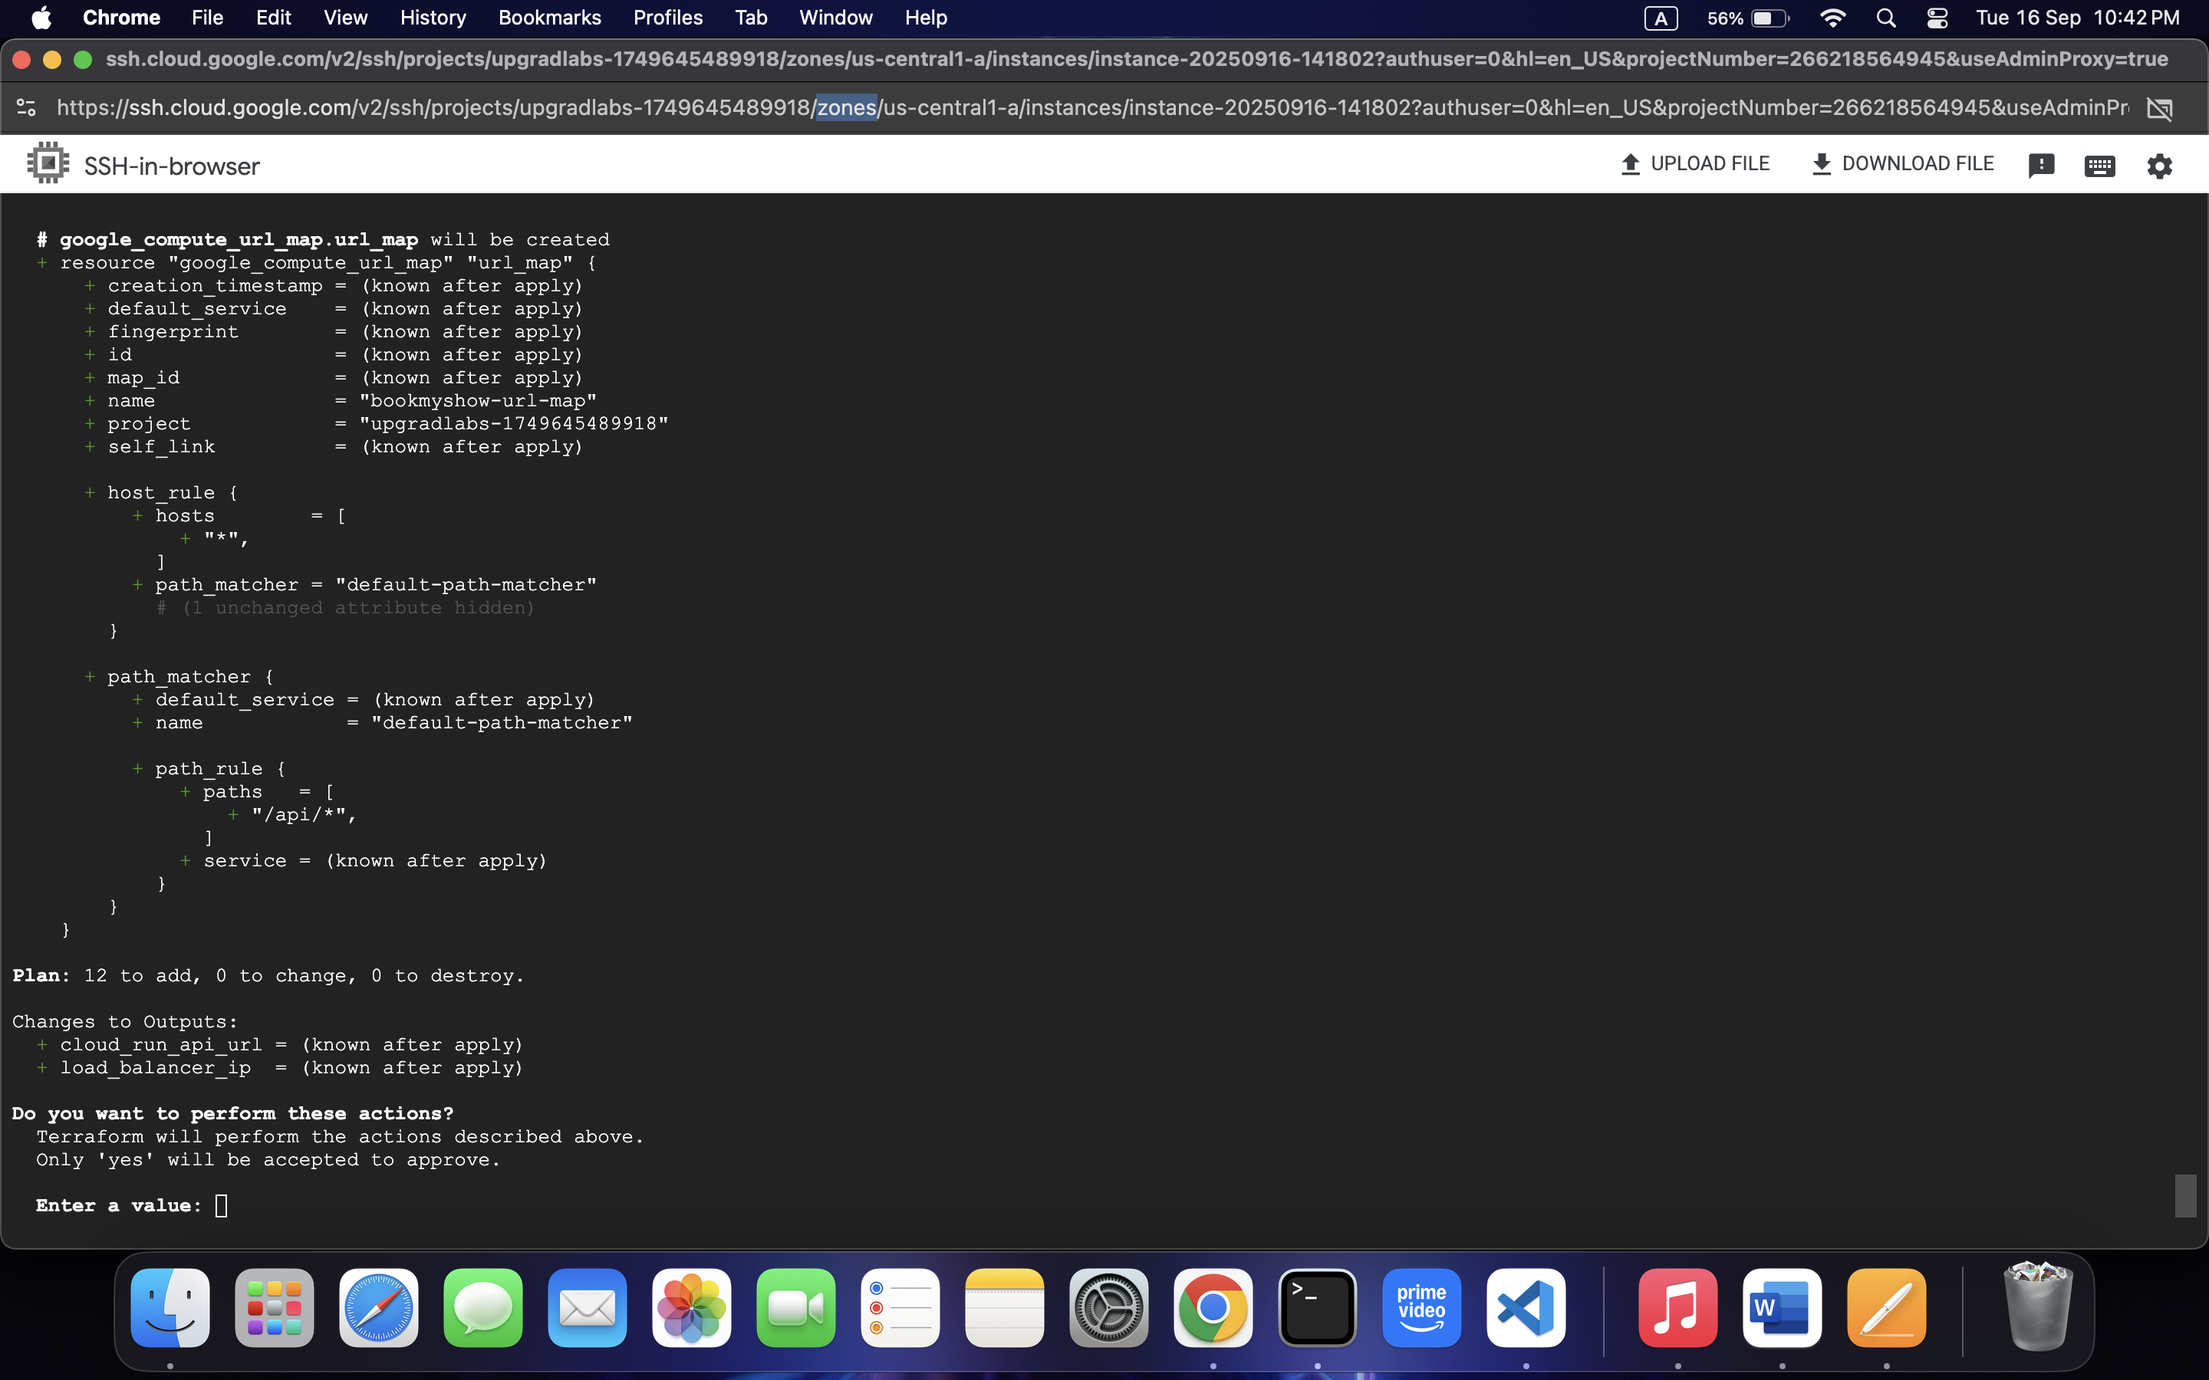

Terraform applied successfully

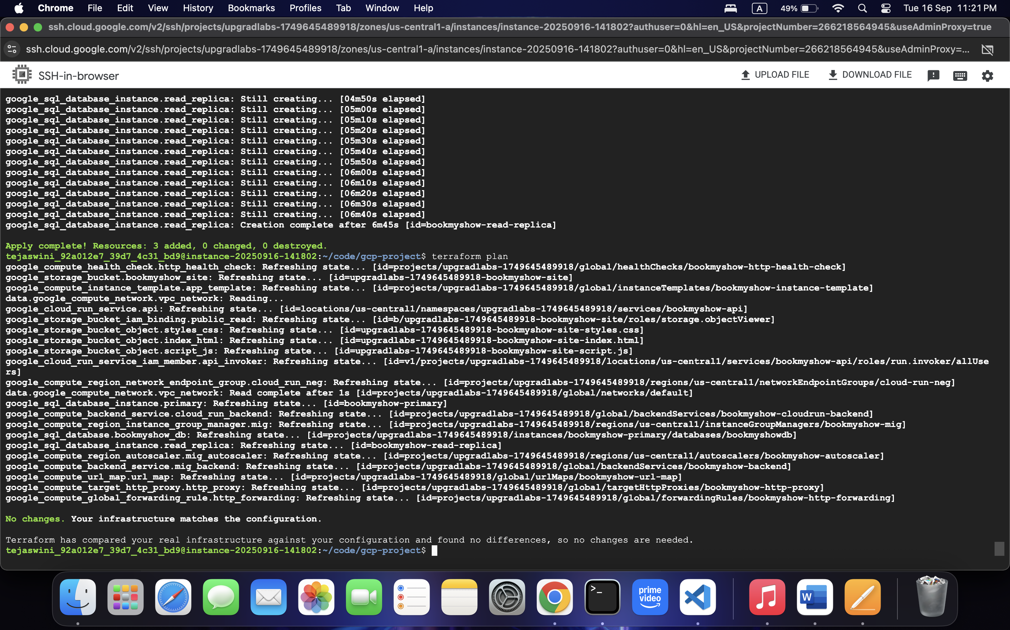

Checked with /api/movies in URL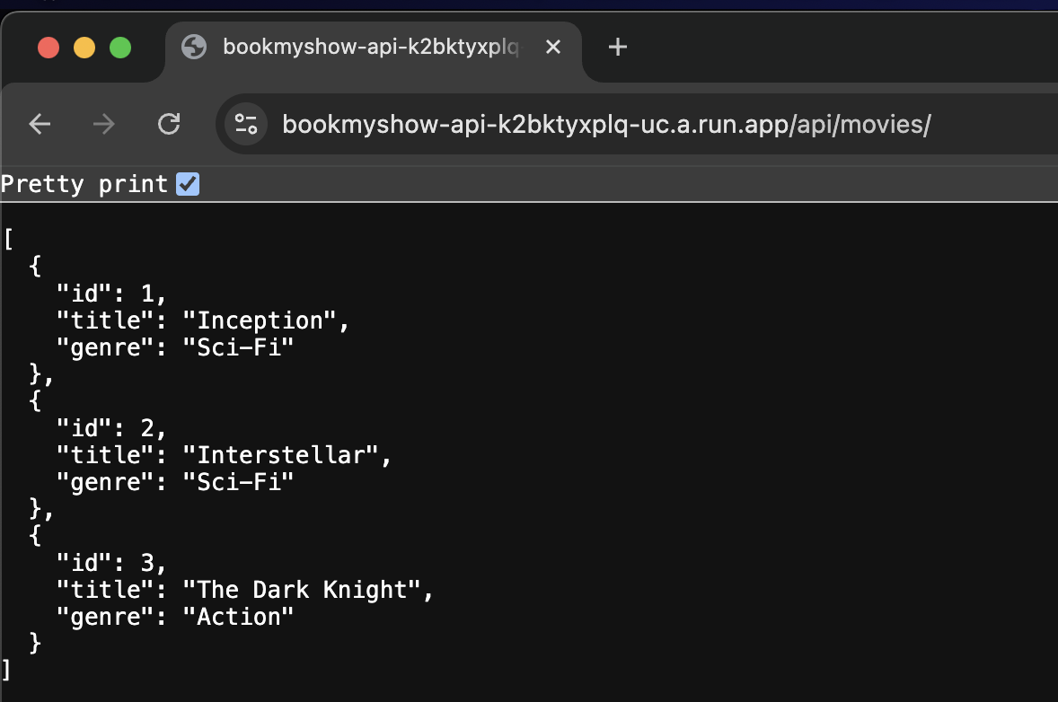  
Front end:

http://upgradlabs-1749645489918-bookmyshow-site.storage.googleapis.com/index.html

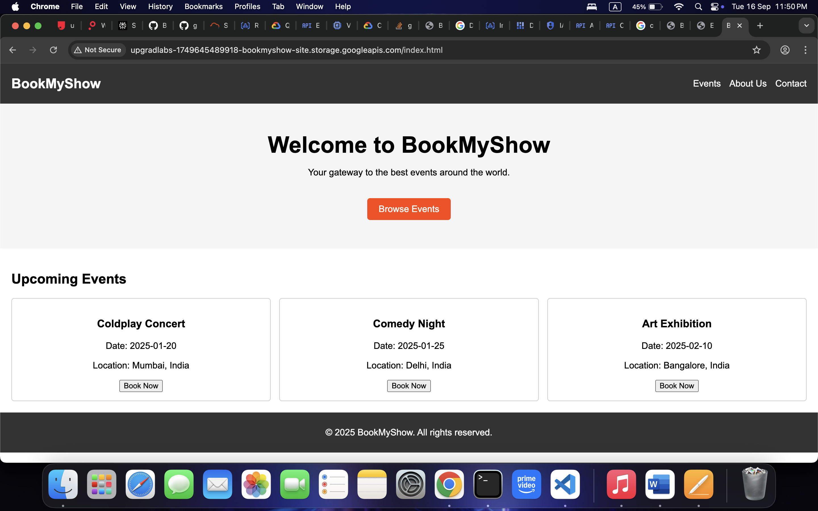

**Backend: https://bookmyshow-api-k2bktyxplq-uc.a.run.app/api/movies/**

**Database connectivity:**

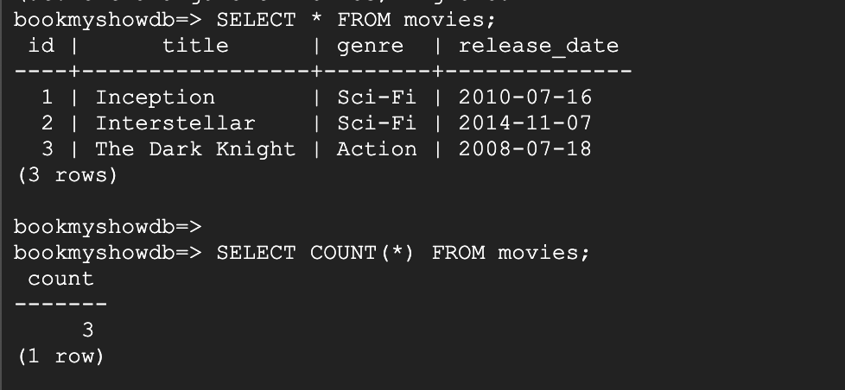

Load Balancer Validation

**http://<ip>**

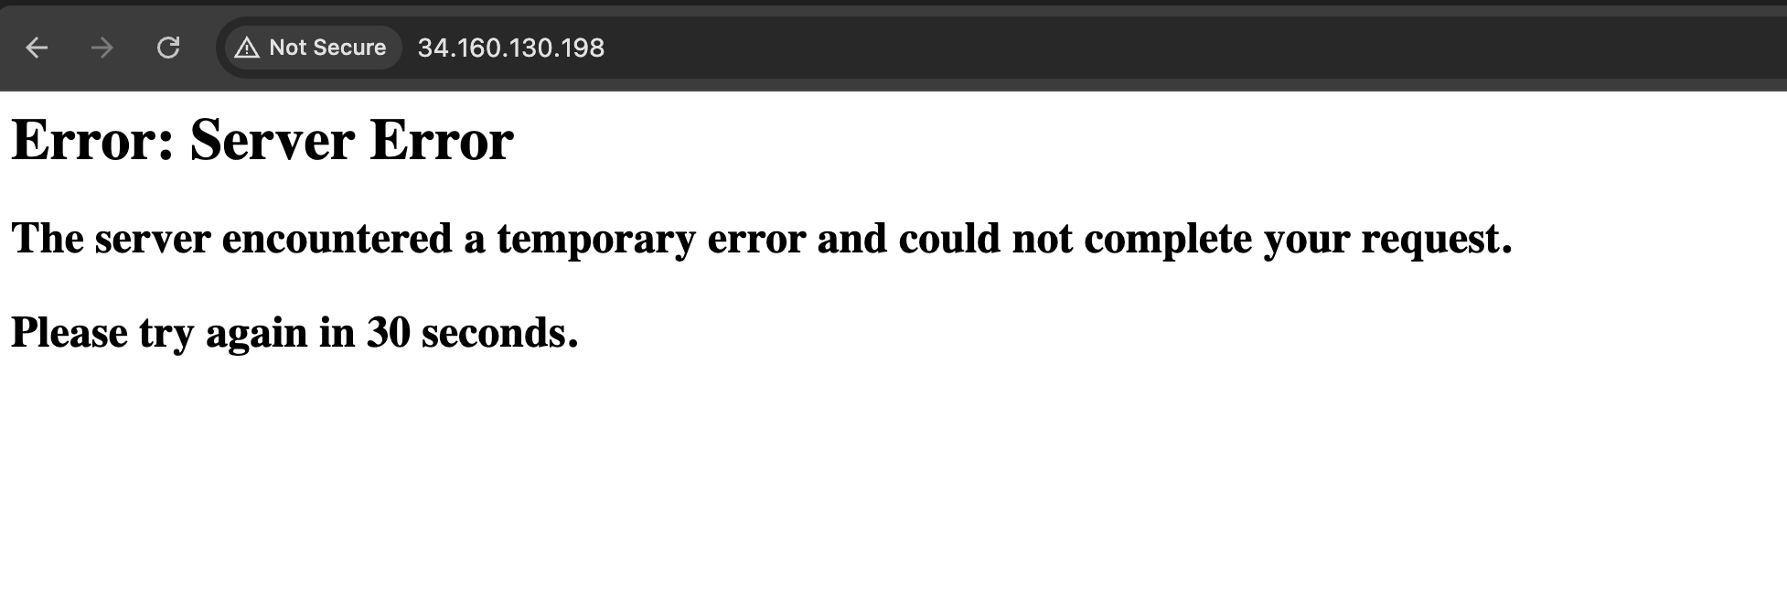

**http://<ip>/api/movies**

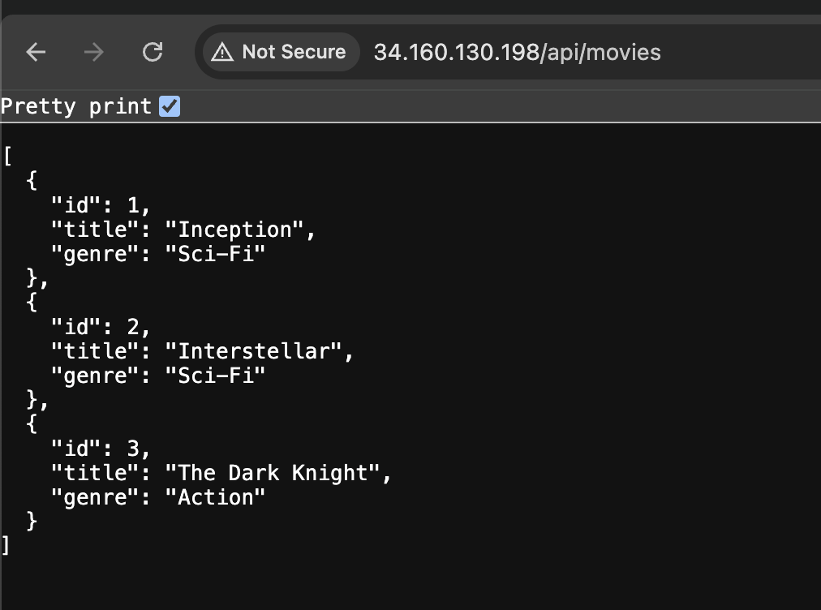

**LoadTest by using Locust: scaling**

